Logging onto ESS:
Access the Employee Self Service Portal (ESS) by clicking on the following link https://ess.srvusd.net:29295. You can also get there by going to SRVUSD home webpage; clicking on the “Staff Resources” tab on the top of the web site and then clicking on the Employee Self Service (ESS) link.
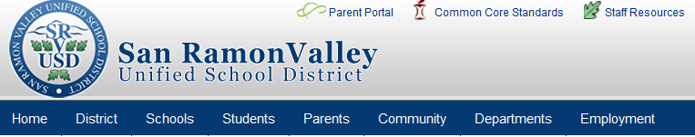

Accessing Employee Self Service - First time user
- At the main page, click on “register “
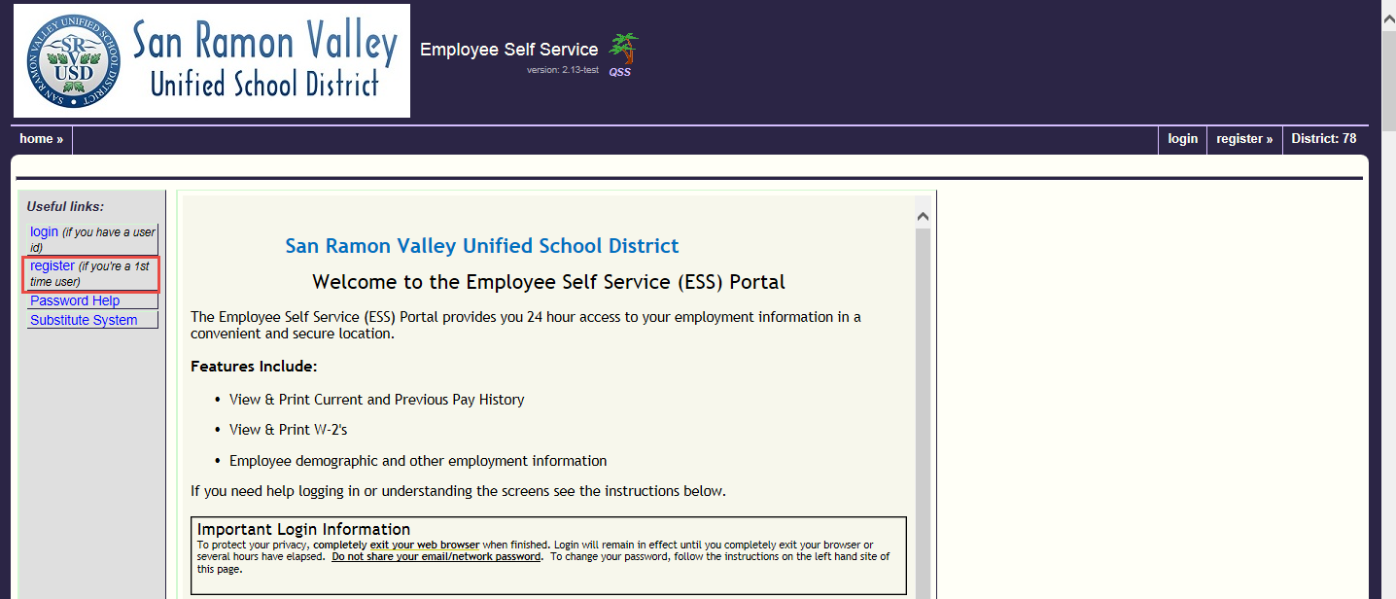

2.) At the Registration Screen, fill in the following fields:

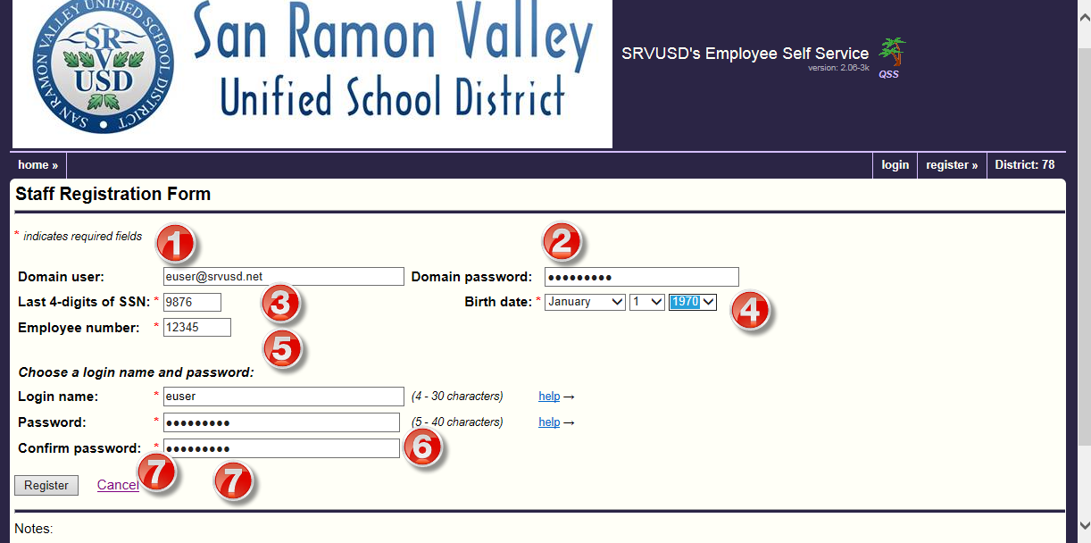

- Domain user: enter your district email username or full email account (example: euser or euser@srvusd.net) – do not use site based email extensions i.e. euser@mvhigh.net
- Domain password: enter your network/email password
- Enter the last 4 digits of your social security number
- Enter your birthdate
- Enter your Employee number: This can be found on the ESS announcement that was sent to your district email
- Login name: prefills automatically with your email name – do not change
Password: automatically fills with your network password – do not change
- Click on Register

Accessing Employee Self Service - Returning user
1.) Now that you have registered, at the main page, click on “login”
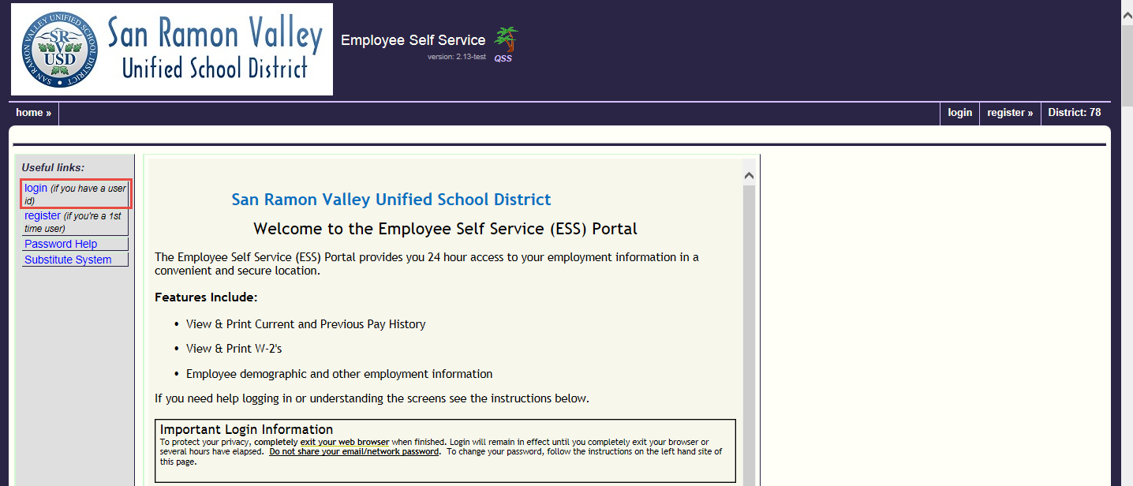
2.) At the Login screen, fill in the following fields:
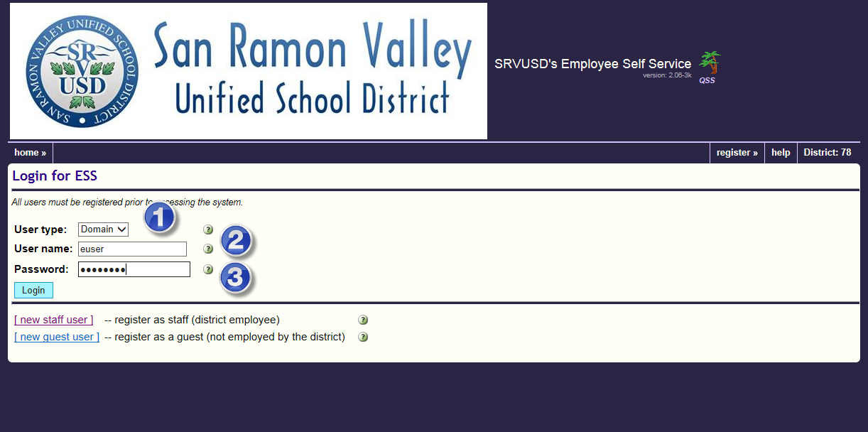
- User Type: enter “Domain”
- User name: enter your email name
- User password: enter your password
- Click on “Login”

Please contact the following departments for questions:
Questions
Type of Questions | Department | Contact /Staff Directory
Email/Password | Technology | emailmanager@srvusd.net
Pay or W-2 Information | Payroll Representative – see staff directory | http://www.srvusd.net/payroll
Personnel Information | HR Representative – see staff directory | http://www.srvusd.net/humanresources

